ESTIMATION OF BUSINESS EXPANSES

**Submitted by**

**NISHANTHINI S F65C818633770A69EE540C4E2C6D518D**

**PRIYADHARSHINI B 6441CF7FCEC25A3B9D0459D751297450**

**SUBHASHINI P 55FF8761B93417A61E4EB8A3F0BBFEA6**

**SRIVARSHINI A 4E31B29A357FD783BC2F41B97B03C5B9A**

**GUIDED BY**

**DR.D. ARUMUGAKANI**

**(Assistant professor)**

**DEPARTMENT OF MATHEMATICS**

**SRI MEENAKSHI GOVERNMENT ARTS COLLEGE FOR WOMEN (A) MADURAI-625002**



Project Report Template

1. INTRODUCTION

1.1 Overview

* Estimating business expenses is a crucial step in financial planning. It involves projecting the cost associated with running a business over a specific period.

* This typically includes fixed costs (like rent, utilities and salaries) and available costs (such as marketing, supplies and maintenance).

1.2 Purpose

* The purpose of estimating business expenses is to gain a clear and realistic understanding of the financial commitments required to operate a business successfully.

* Estimate employee salaries and benefits, accounting for potential changes like raises, new hires, or terminations.

2. PROBLEM DEFINITION & DESIGN THINKING

2.1 Empathy Map:

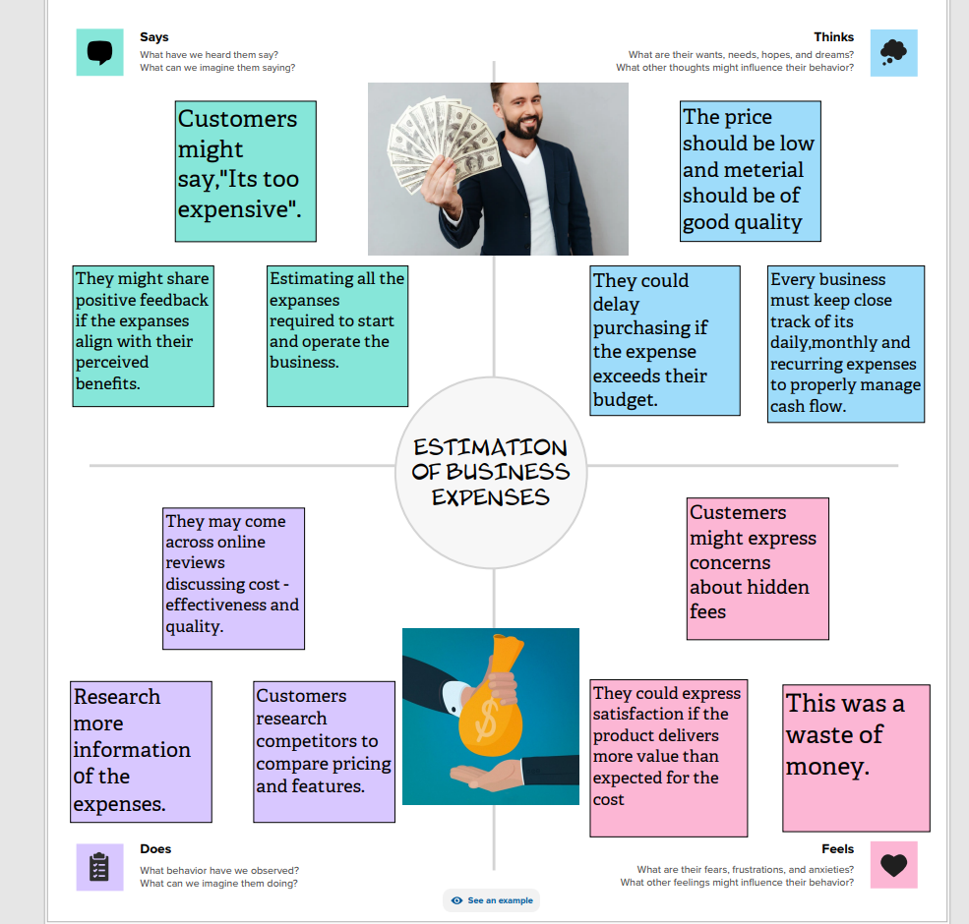

2.2 IDEATION & BRAINSTORMING MAP

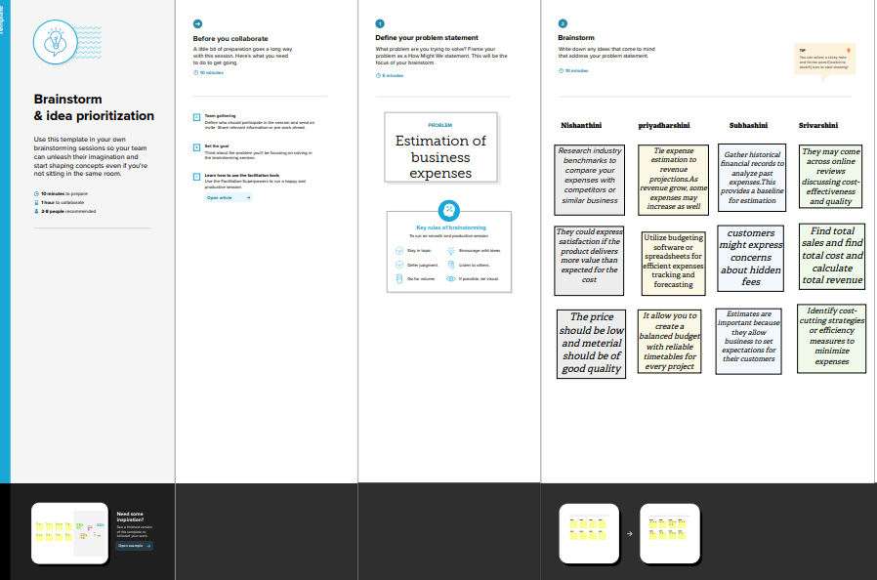

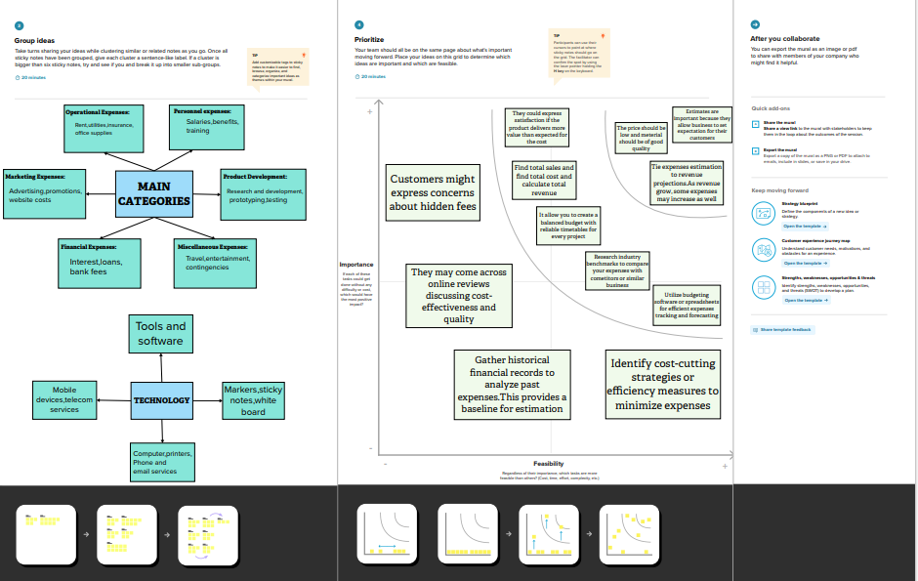

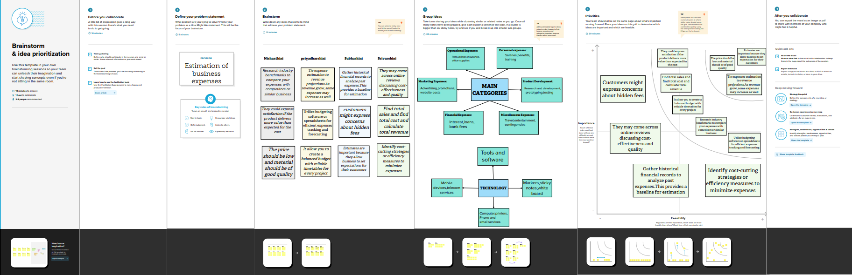

3. RESULT

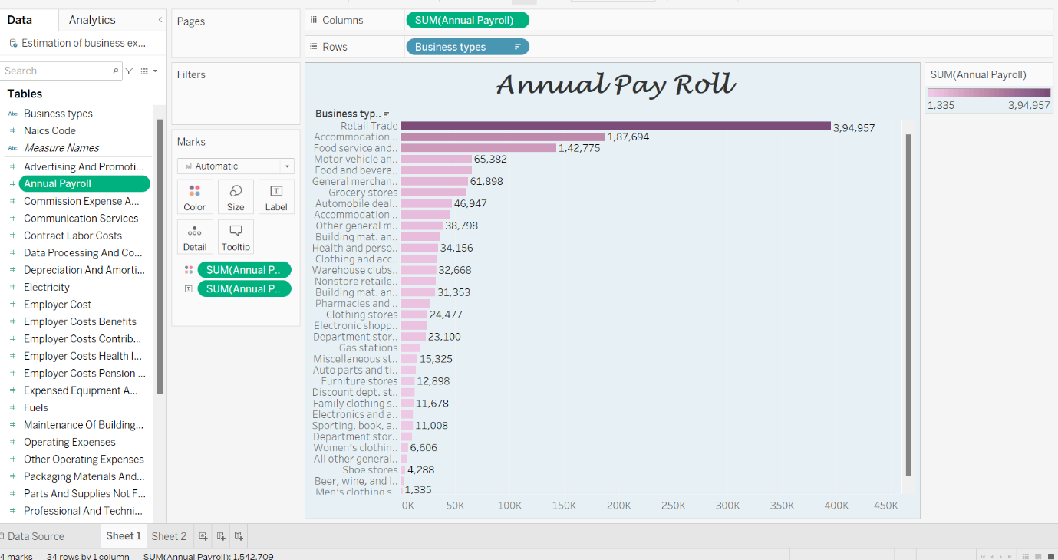

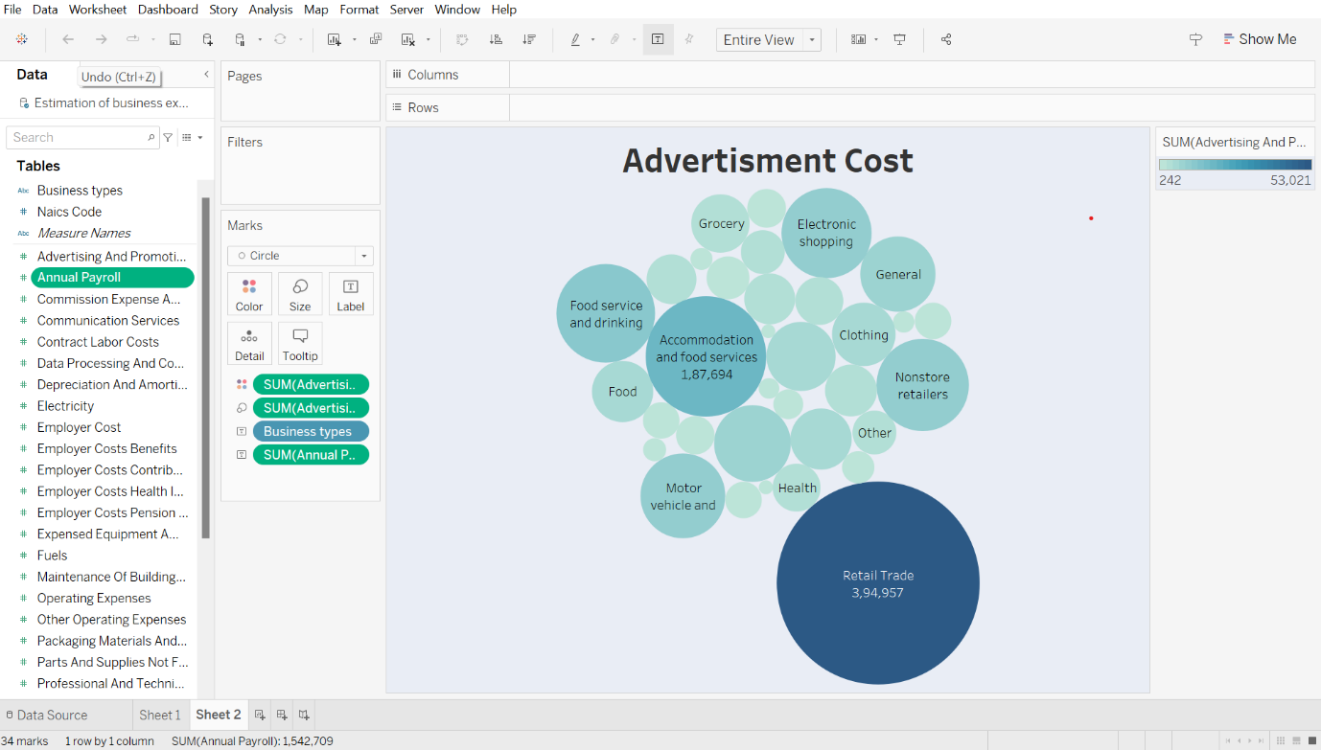

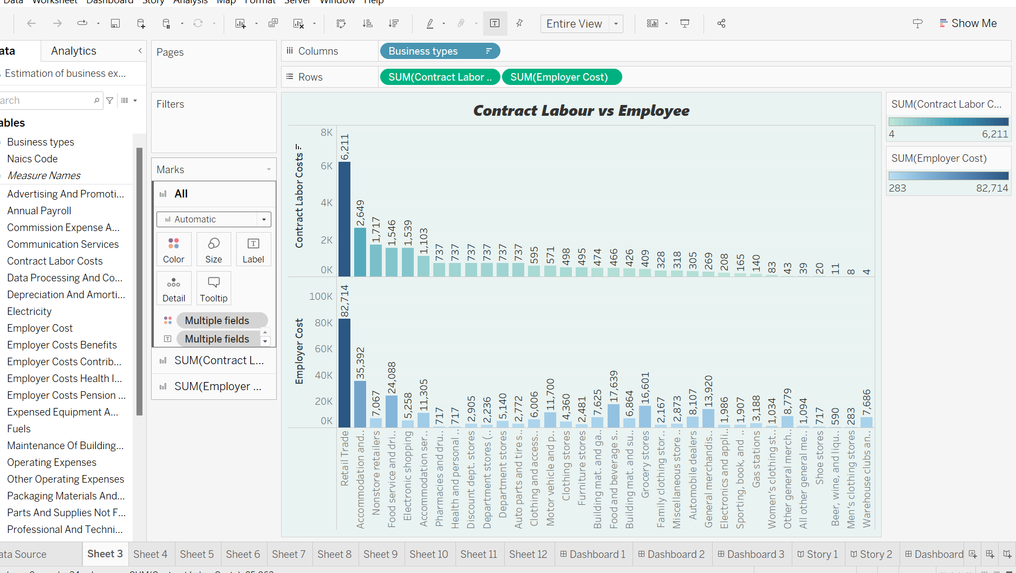

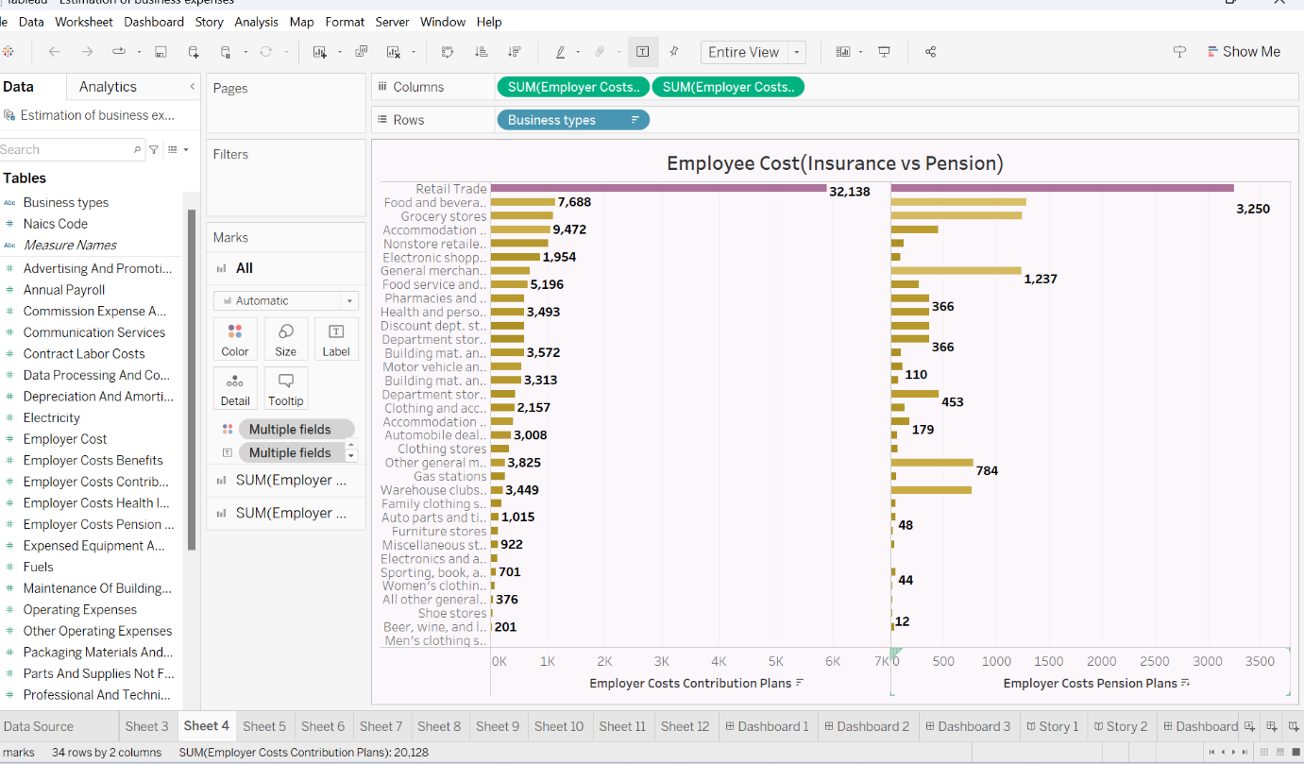

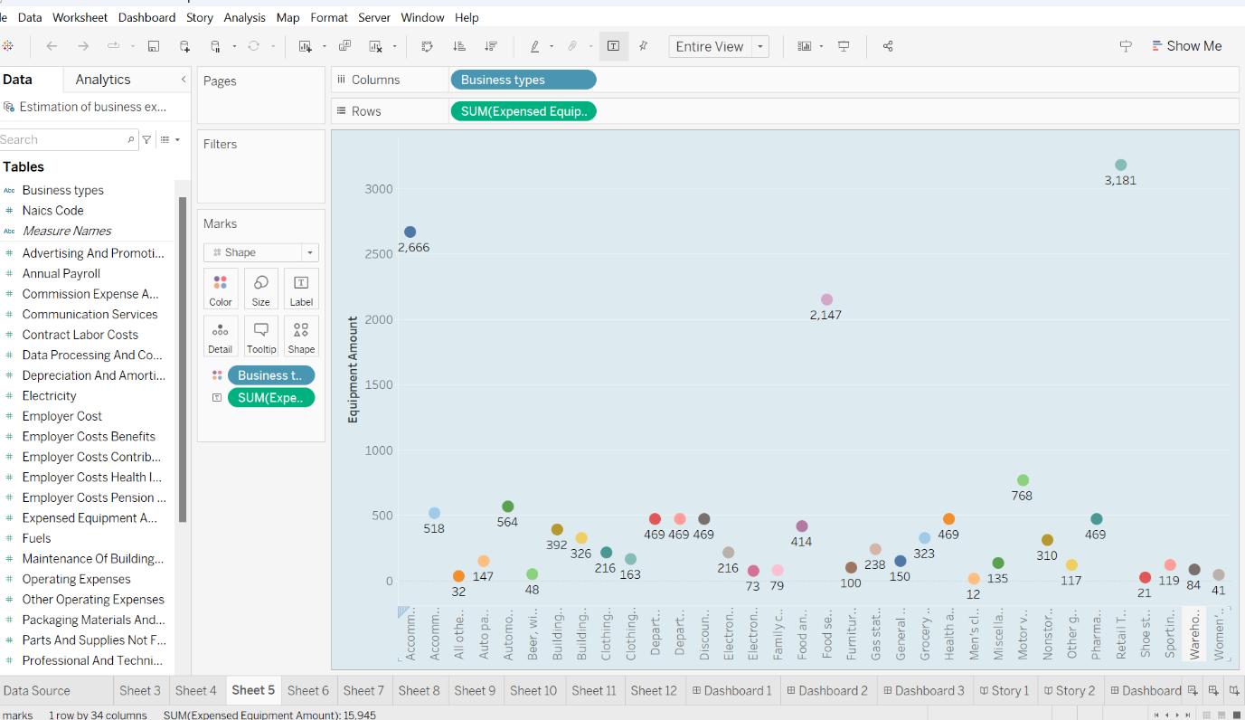

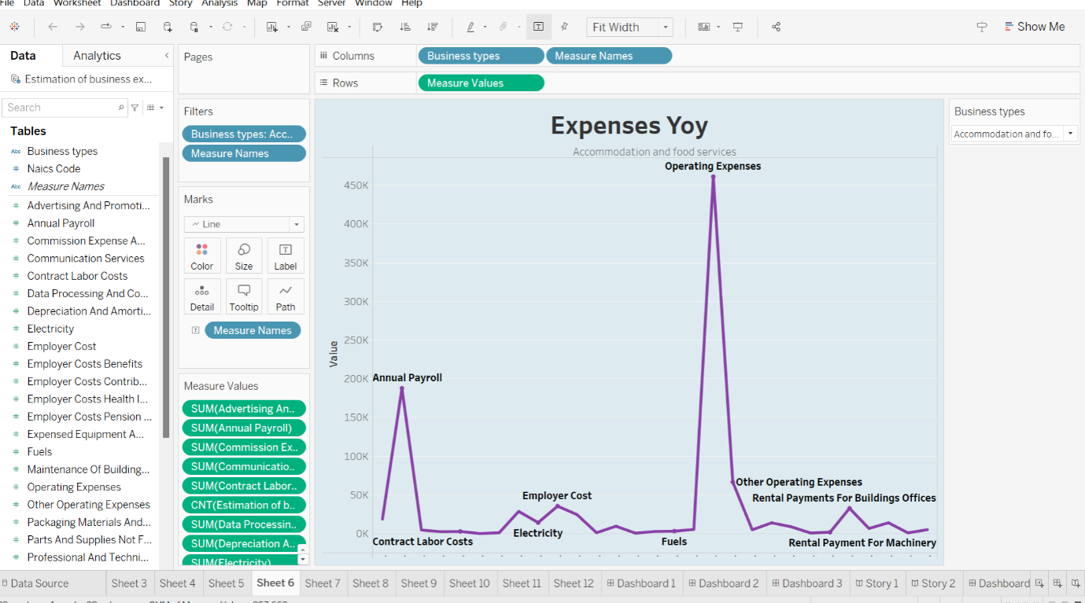

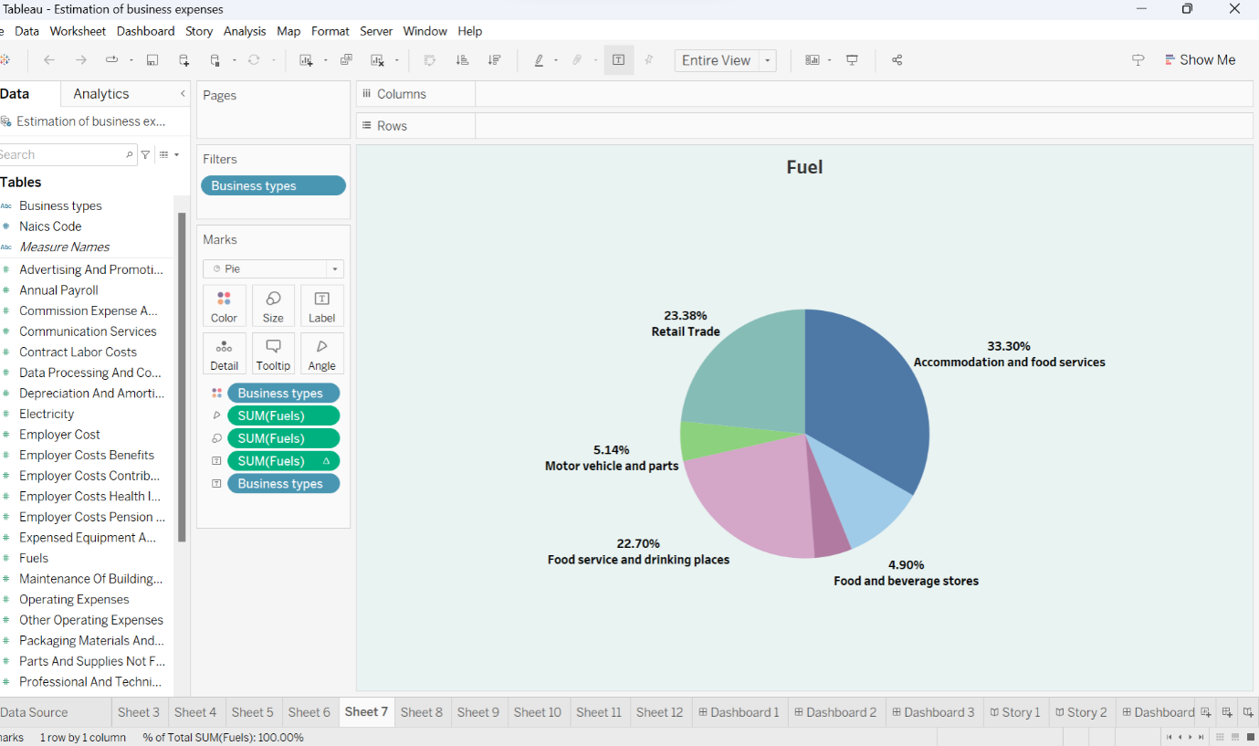

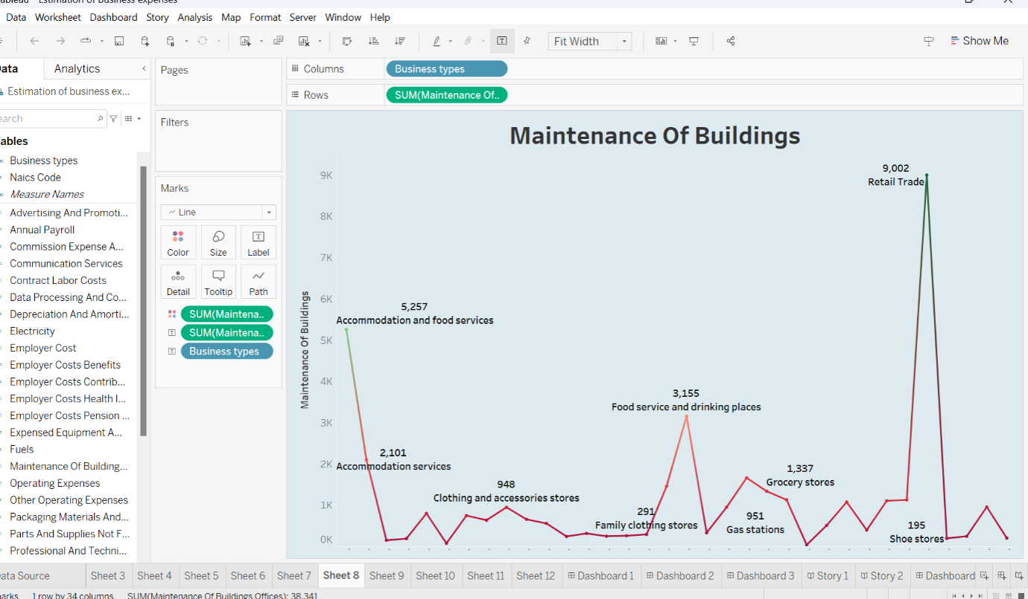

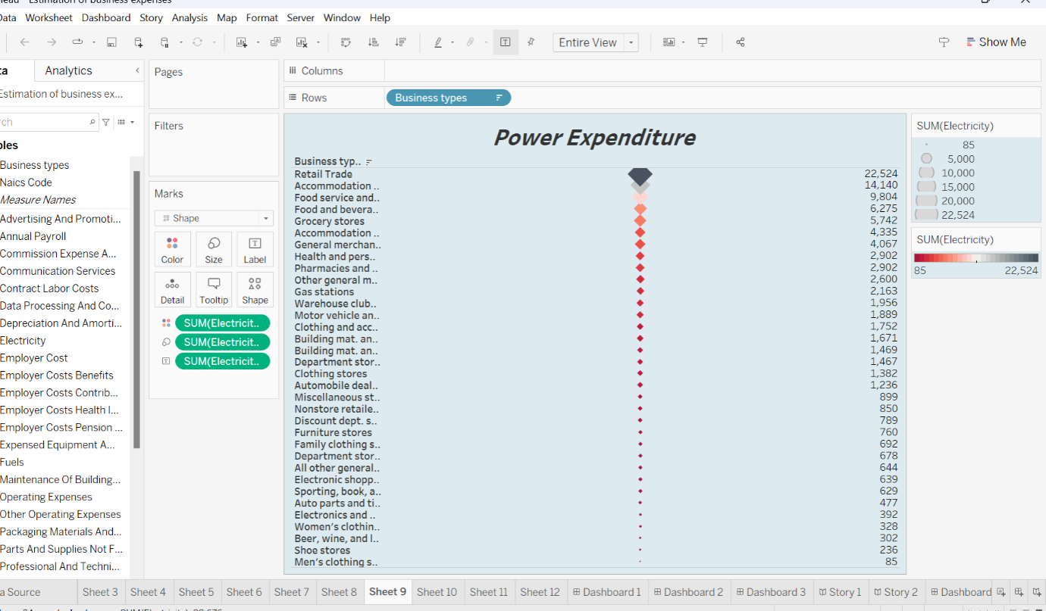

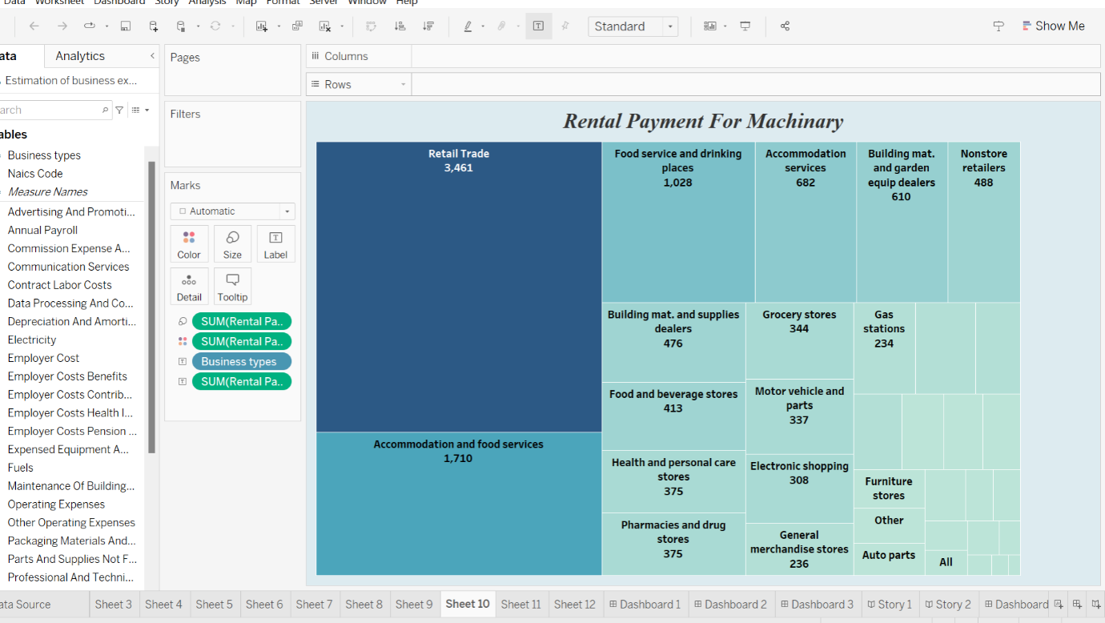

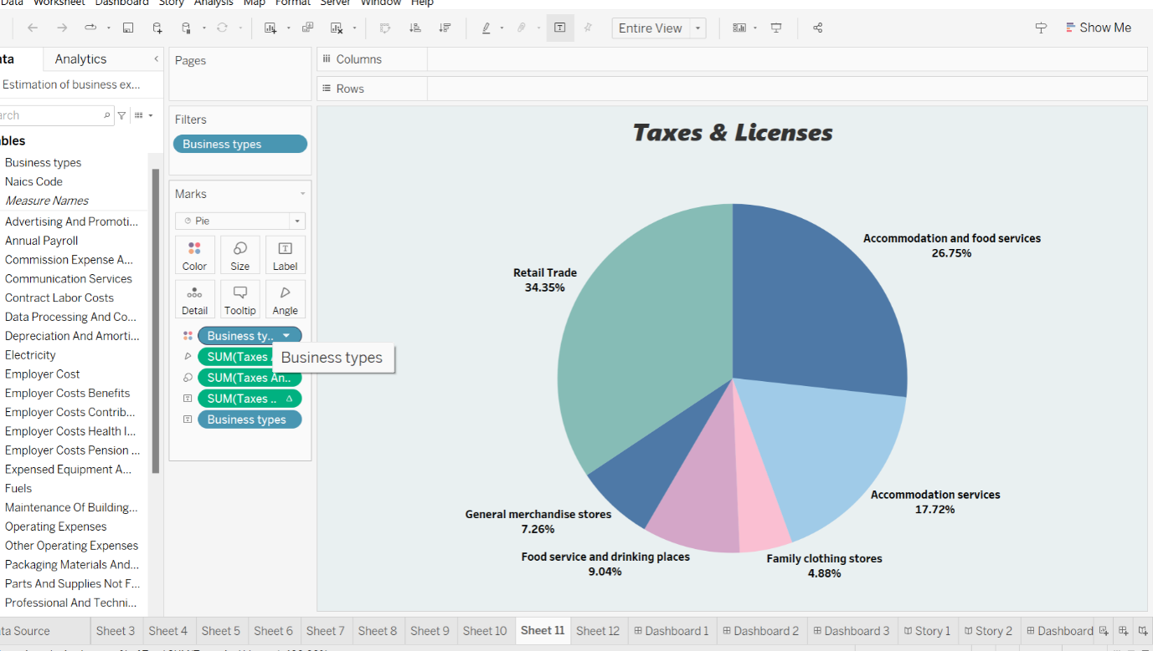

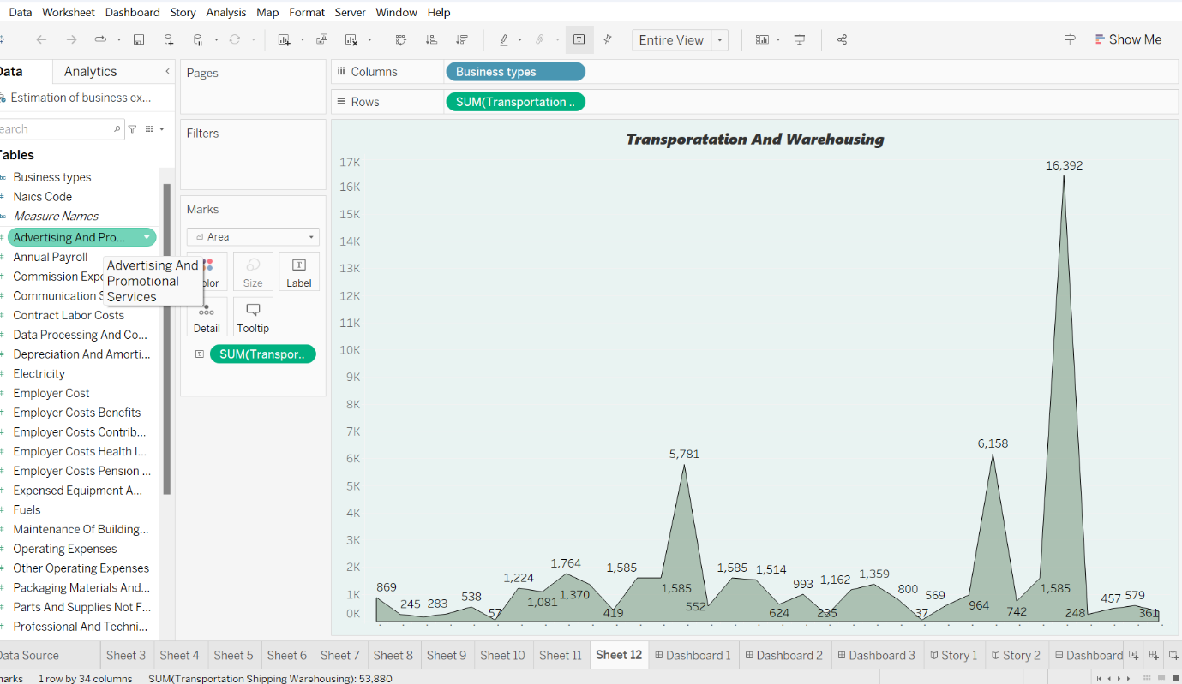

**4.ADVANTAGES & DISADVANTAGES**

***Advantages:***

**\* Expense estimation helps businesses plane and allocate resources effectively, ensuring they have the funds necessary to cover costs.**

**\* It enables the creation of budgets, which are essential for tracking and controlling expenses to prevent overspending.**

**\* Demonstrating accurate expense estimates can attract investors or lenders, as it reflects financial responsibility.**

**\* Supports tax planning, ensuring businesses are prepared to met their tax obligations and take advantage of available deductions.**

**\* Estimation aids in managing cash flow effectively to ensure there is enough liquidity to meet financial obligations.**

***Disadvantages:***

**\* Estimates may not always reflect actual expenses, leading to potential financial shortfalls or overestimation of costs.**

**\* It can be a time-consuming process, requiring data analysis and constant updates to remain accurate.**

**\* Inaccurate estimates can result in costly errors, such as underestimating expenses and causing financial instability**

**\* Once a budget is set, it may be difficult to adapt to changing circumstances without significant adjustment.**

**\* There’s a risk of either overestimating expenses, leading to unnecessarily conservative budgeting, or underestimating, which can result in financial strain.**

**5. APPLICATION:**

**\* Businesses often use expense reports to compile and track expenses, which are then formally reported by accountants on financial statements, like the income statement. However, when an expense is reported depends on the type of accounting the business uses: the accrual basic or the cash basic of accounting.**

**6.CONCLUTION:**

**\* Expenses are an inevitable aspect of running a company. General and administrative expenses, research and development costs, and the cost of goods sold are all examples of operating expenses. If your operating expenses grow higher, then it seems to lower the business profitability of the company.**

**7. FUTURE SCOPE**

**\* In the future accurate and efficient estimation of business expenses will be critical for maintaining financial health, making informed decisions, and staying competitive. The adaption of advanced technologies and data-driven approaches will be key in achieving these goals.**

**THANK YOU**